|  |  |
| --- | --- |
| Feature | Score |
| 1. feature 20 (sensorCount-Kitchen) | (0.153283) |
| 2. feature 0 (lastSensorEventHours) | (0.087287) |
| 3. feature 1 (lastSensorEventSeconds) | (0.085212) |
| 4. feature 9 (lastMotionLocation) | (0.067567) |
| 5. feature 21 (sensorCount-LivingRoom) | (0.036598) |
| 6. feature 27 (sensorElTime-Chair) | (0.036238) |
| 7. feature 31 (sensorElTime-Kitchen) | (0.035192) |
| 8. feature 34 (sensorElTime-OutsideDoor) | (0.033122) |
| 9. feature 2 (lastSensorEventSeconds) | (0.033049) |
| 10. feature 8 (lastSensorLocation) | (0.032816) |

### **Random Forest Classifier**

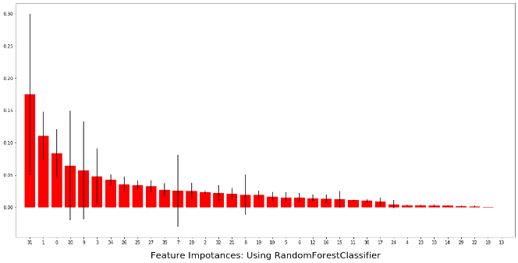

**Figure 7: Random Forest Classifier Feature Score**

**Table 4: Top 10 Significant feature score in Random Forest Classifier**

|  |  |
| --- | --- |
| Feature | Score |
| 1. feature 31 (sensorElTime-Kitchen) | (0.149931) |
| 2. feature 1 (lastSensorEventSeconds) | (0.116110) |
| 3. feature 20 (sensorCount-Kitchen) | (0.091917) |
| 4. feature 0 (lastSensorEventHours) | (0.080503) |
| 5. feature 3 (windowDuration) | (0.055434) |
| 6. feature 9 (lastMotionLocation) | (0.045336) |
| 7. feature 34 (sensorElTime-Kitchen) | (0.041218) |
| 8. feature 25 (sensorElTime-Bathroom) | (0.035567) |
| 9. feature 26 (sensorElTime-Bedroom) | (0.035500) |
| 10. feature 27 (sensorElTime-Chair) | (0.031554) |

## **Backward Elimination Output**

Using Variance Threshold baseline approach, we have executed Backward Elimination algorithm on the dataset,

The two columns that are found most significant through this technique are “lastSensorEventSeconds, sensorElTime-Bedroom.” Figure 8 presents the statistical significance calculation of each of the column attributes with respective to p-value, t-test and standard error.